Michael Fertig

I decided on doing the word counting assignment. So, the first idea I thought up of was to pass the input into a loop that would manually count each space. However, while testing I noticed that it caused issues when say a user would double space by mistake. I decided to look up string manipulation methods for Javascript and found other people attempting to do a similar word counter. Through looking up suggestions there I found several suggestions to use the regex /\s+/, which lead me down a rabbit hole of regex. From there I used this regex expression, and some built in JS string manipulation methods to determine the total amount of words in the text.

For variables we have count, which is a reference to the count on the HTML page. Input, which is a reference to the textarea and String, which holds the users input.

Here is an example of the code working:

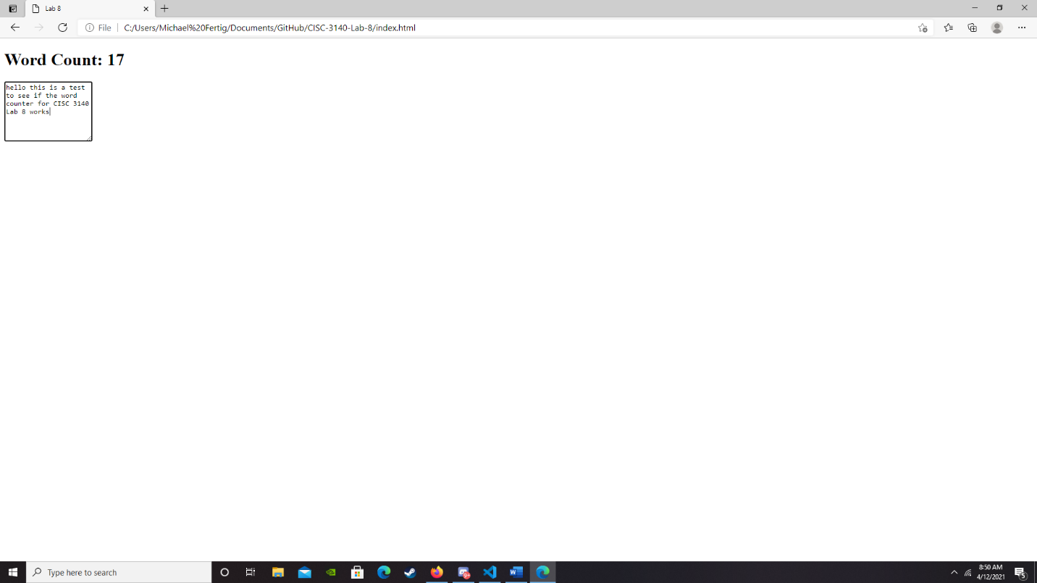

Also, I do have an issue that I cant seem to fix but if I delete everything then it still says “word count: 1”:

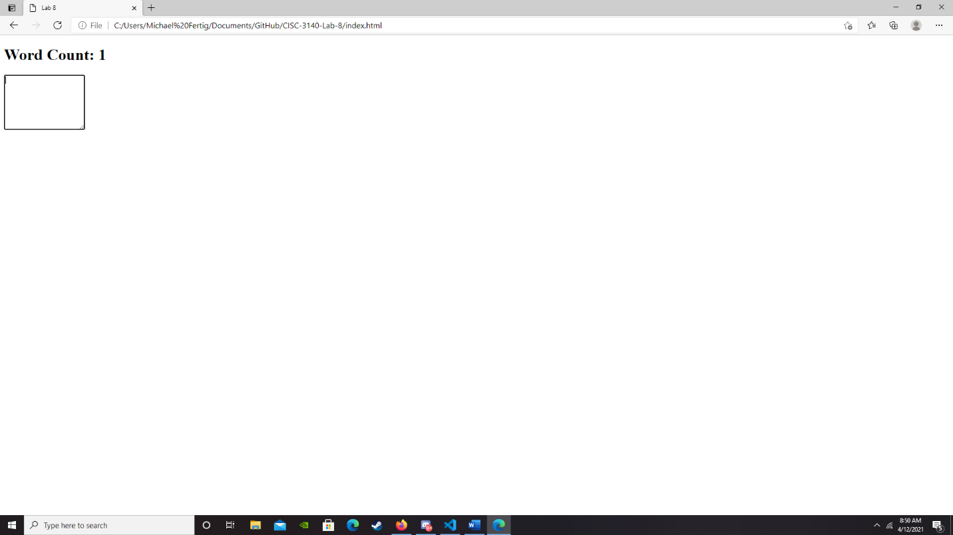

However, if I type after then the word count still goes up normally so I used it to be a non-issue.